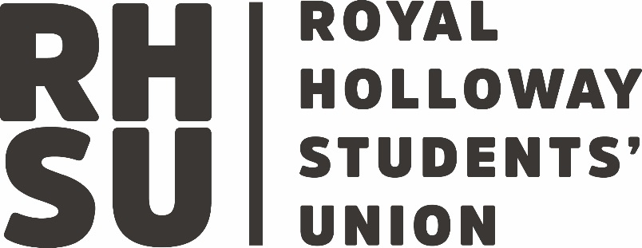

|  |  |
| --- | --- |
| **Policy Title:** | Withdrawal of Service Policy and Procedure |
| **Policy Owner:** | Advice Centre |
| **Date of Policy:** | July 2025 |
| **Version Number** | 2 |
| **Policy Review Date:** | July 2027 |

1. **Aim**

The Students’ Union’s Advice Centre offers independent, confidential advice to all Royal Holloway University students on a range of issues but particularly specialising in housing, academic and general wellbeing support.

There may be occasions or circumstances where it would no longer be appropriate for the Advice Centre to continue offering support to a student and this would result in a withdrawal of service.

The aim of this policy is to set out the circumstances under which withdrawal of service will be invoked. Any withdrawal of service will be invoked in line with one of the following principles:

1. To support, and ensure resource for, the growing number of appointments we take, offering a service which is accessible and available to all students.
2. To safeguard the welfare of our Advisors.
3. **Withdrawal of service causes**

Any decision to withdraw service from an individual will not be taken lightly and will usually be made in relation to one of the following causes:

1. Conflict of interest   
   Advisors are unable to advise a student on a course of action that could be potentially damaging to the Students’ Union staff (including elected sabbatical officers) or services. For example, we cannot advise individuals on employment issues if the Students’ Union is your employer. In such cases the adviser will provide the student with details of alternative advice services.
2. Loss of confidence  
   In order for our Advisors to effectively support a wide range of students’ needs, it is essential that appointments are not wasted. Repeated failure to either attend appointments (two or more missed appointments), to give accurate and honest information or to respond to messages in a reasonable amount of time may result in withdrawal of service. If a student is unable to attend an appointment, they should inform the Adviser or the Helpdesk by phone or in person.

The most effective support comes from a place of mutual respect, courtesy and understanding between Advisors and students. As such, our Advisors do expect students to carefully consider all options and advice discussed during appointments and will respect the right of all students to make their own decisions. However, where advice on the same matter is repeatedly ignored, or a student continues to pursue a course of action against the advice of staff, the service may be withdrawn as it is no longer of productive use to the student.

1. Unreasonable behaviour  
   Staff accept that there are occasions when a student may be upset and less able to control their emotions but any kind of harassment, abuse, aggression, threat or inappropriate behaviour towards staff will not be tolerated. In the first instance it may be appropriate to issue a warning that services may be withdrawn if the behaviour continues but this may not always be the case and there may be circumstances where it is appropriate for a withdrawal of service to be issued immediately. If a student has been warned and continues to demonstrate unreasonable behaviour the service will be withdrawn, and the student will be reported and dealt with according to the Members' Disciplinary Procedure (Byelaw L of the Students’ Union’s constitution).
2. Dependence on the service  
   It is expected that the majority of students will only require one or two appointments with an Advisor to receive the support and guidance necessary for their circumstances. However, it is accepted that some cases will be more complicated than others and will require ongoing support over a period of weeks. It should be understood, however, that our Advisors are not trained or qualified Counsellors and will signpost individuals to appropriate services where this specific skill is required. As such we want to dissuade individuals from using the service in this manner. Where our Advisors believe that a pseudo counselling service is being sought, they will invoke a withdrawal of service.
3. **Procedure**

The following process will be followed where withdrawal of service has been identified:

1. In the first instance, where appropriate, a student will be given a warning, either verbally or via email, that repeated action will result in a withdrawal of service.
2. Where the behaviour continues, the Advisor will seek support from the Advice Centre Manager. Once the withdrawal is confirmed, the Advice Centre Manager will email the student. Alternative places where advice can be sought will be provided.
3. Any student who is a recipient of a withdrawal of service may be able to access the Advice Centre again in the future for a different case, however any future appointment should be checked with the Advice Centre Manager. Where unreasonable behaviour was identified as the cause for withdrawing the service, access to the service could be withdrawn permanently, depending on severity and pending the outcome of any investigations.