Staff-Student Action Log |  | 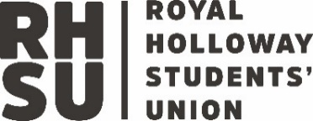
Purpose | The core purpose of the academic representation system, which aligns with the revised UK Quality Code, is to achieve positive change that improves the educational experience of students at Royal Holloway and engages students as partners in the development, assurance, and enhancement of their learning.
Reports to | School Education Committee – UG and PGT  School Research Student Oversight Committee - PGR
Department
Regular meetings per year | 3-6
Quorum | 5

Attendance Monitoring
 | Date and Time | Location | Attendance
November Meeting (compulsory)
December Meeting (optional)
February Meeting (compulsory)
March Meeting (optional)
April Meeting (compulsory)
May Meeting (optional)

Actions

Action No. | Agreed Action  (Include reason for agreed action) | Date Action Agreed | Responsible | Due | Date Action Completed | Outcome

Notes:
Feel free to use this space to make note of anything of importance, in addition to the actions above, that don’t require an action.

Notes
Meeting 1
Meeting 2
Meeting 3
Meeting 4
Meeting 5
Meeting 6

