Committee Agenda  Staff-Student Action Meeting |  | 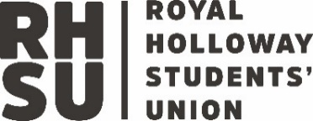
Purpose | The core purpose of the academic representation system, which aligns with the revised UK Quality Code, is to achieve positive change that improves the educational experience of students at Royal Holloway and engages students as partners in the development, assurance, and enhancement of their learning.
Reports to | School Education Committee – UG and PGT School Research Student Oversight Committee - PGR
Sub-committees | As relevant per Department
Regular meetings per year | 3-6
Quorum | 5
Route for submission of business | Submissions to staff lead and Senior Course Rep
Agenda and papers
Approved by/on

Agenda
Item | Item | Owner | Document
1 | Academic Staff Update
2 | Academic Rep Update
3 | EDI Update
4
5
AOB

