Staff-Student Action Meetings – Introduced for 2023/24
Firstly, we would like to thank you for getting involved in academic representation for the 2023/24 academic year. We are excited to have you on board and we look forward to working with you and seeing the work that goes into improving the academic experience for students at Royal Holloway. A lot has changed in the world of academic representation here at RHUL over the last couple of years so this document will explain all you need to know to get you up to speed ahead of the first term.
We have been making some changes to improve academic representation at Royal Holloway and this year, we are introducing a new system called Staff-Student Action Meeting (SSAM) which will be rolled out across all six schools and each level of study. As part of this system, reps and identified members of staff will be responsible for meeting at least once per term and maintaining Action Logs which will act as a way of identifying solutions and tracking progress of student feedback.
A compulsory meeting will take place for each level of study and department in November, January and April and additional optional meetings can take place if individual department’s feel as though they are necessary in December, March, and May.
The compulsory meetings should be arranged to take place during the following weeks:
- W/C 6 November 2023
- W/C 29 January 2024
- W/C 29 April 2024

Optional additional meetings should take place during the following weeks:
- W/C 4 December
- W/C 4 March
- W/C 20 May

How do Staff-Student Action Meetings work?
- Course Reps and Senior Couse Reps attend the SSAM meeting for their department and level of study at least once per term and identified key members of staff should also be present.
- Course Reps should speak to students ahead of the meeting and gather any feedback they have that they would like to raise. There is a form template reps can use to gather feedback which you can find on the Rep Hub.
- Course Reps will then liaise with Senior Course Reps in their department to make them aware of the issues and what should be discussed in the meeting based on the student feedback.
- Senior Course Reps send all feedback to an identified member of staff at least two weeks ahead of the SSAM who will add each point onto the agenda for the meeting.
- The identified member of staff should select a date and time within the weeks outlined above and invite all attendees (Course Reps, Senior Course Reps, and staff) with plenty of notice and include important details such as time, date, and location along with the agenda and any other useful documents.
- At Undergraduate and Postgraduate Taught levels of study, one Senior Course Rep will chair the meeting and at Postgraduate Research, a Course Rep will chair.
- In the meeting, the chair should go through each agenda point and invite attendees to discuss the issue and identify solutions to create positive change for the students who originally raised the feedback.
- Staff will have the opportunity to update reps on developments happening behind the scenes that may be useful for them to know.
- Identified members of staff and Senior Course Reps will record identified actions which need to be completed as part of the ‘Staff-Student Action Log’. These logs are a live document which are to be hosted in an individual department MS Teams channel which will be created by the Students’ Union Voice Team and accessible to all reps in that department and level of study. This is so that students who don’t attend SSAM can be updated on what is being discussed and how their feedback is being acted upon so they should be updated regularly to highlight where actions have been completed and what the outcome is.

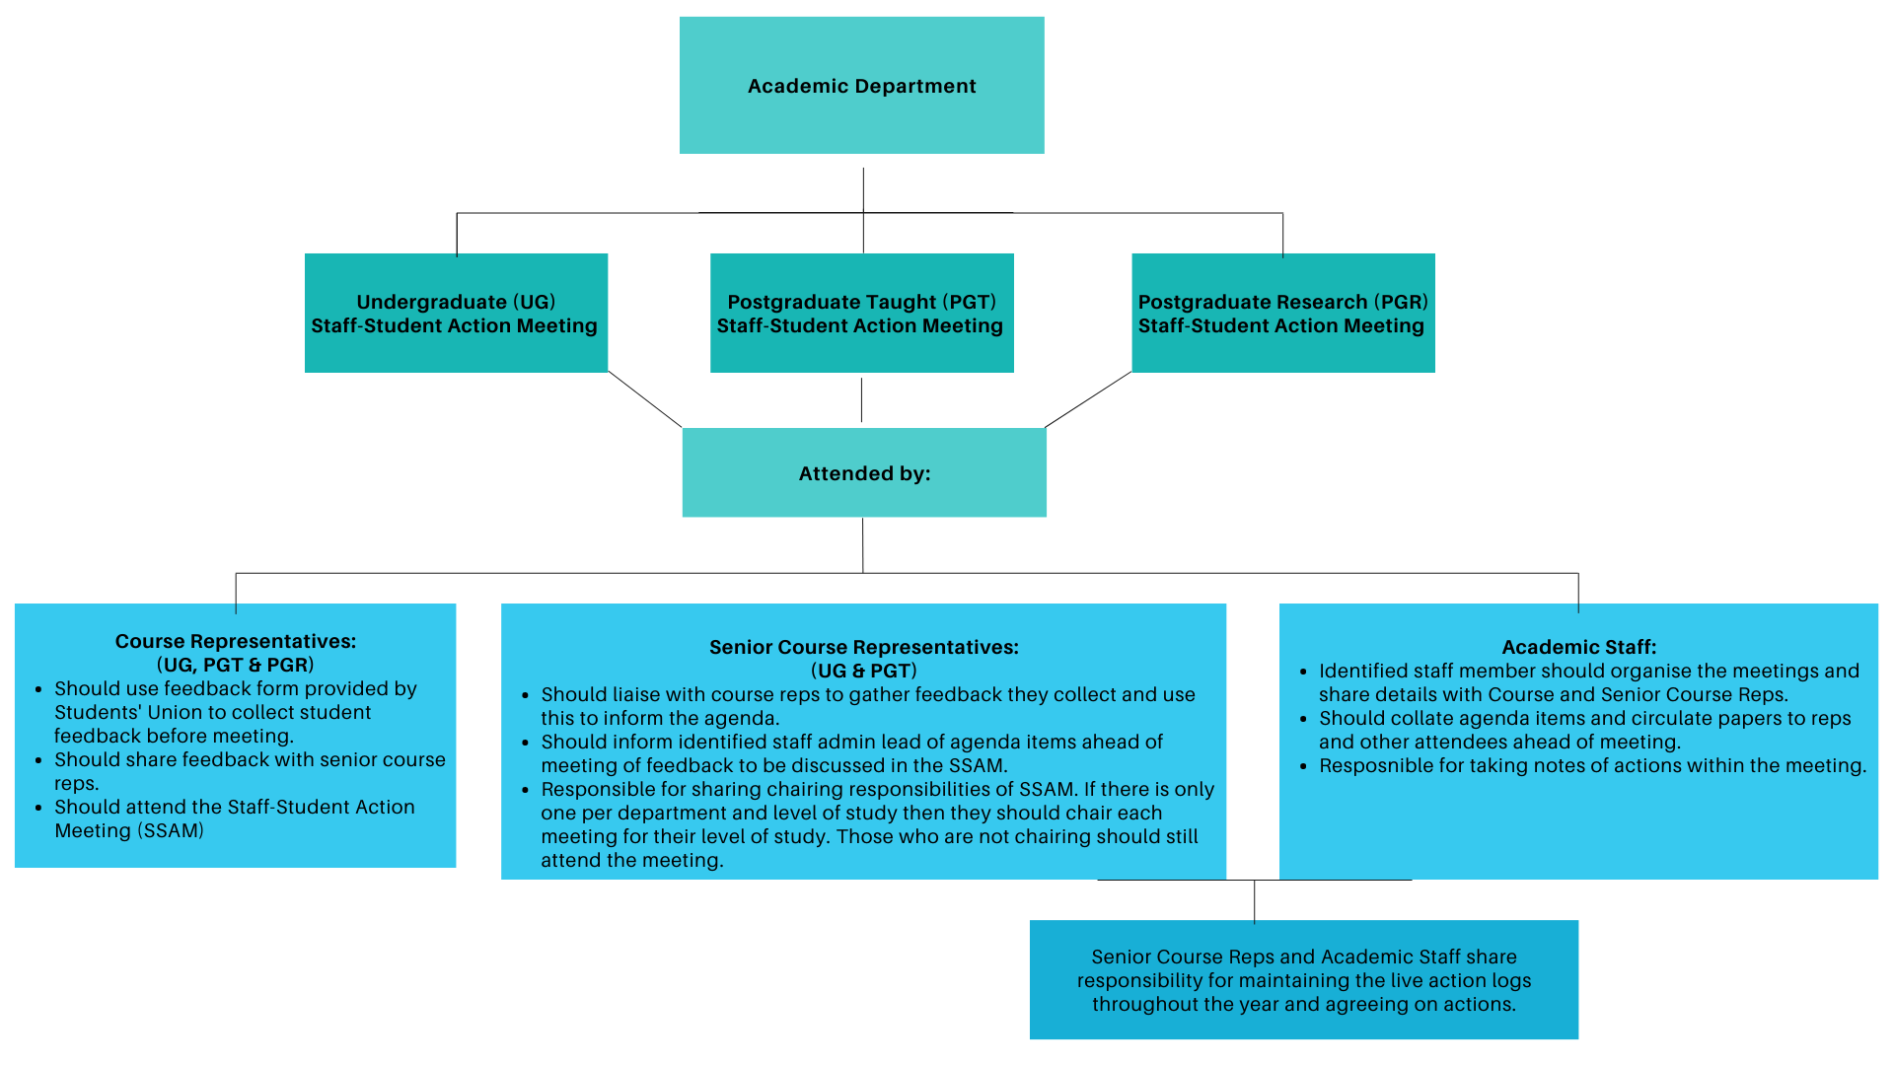
The model and responsibilities are summarised below:

If you have any questions about the SSAM structure or academic representation in general, then please don’t hesitate to contact the student voice team at voice@su.rhul.ac.uk and a member of the team will be happy to help.

Department Name:

Key Contact name | Role | Email Address

List of Courses:

