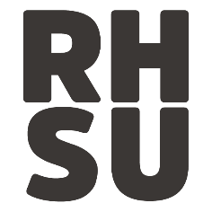

“Royal Holloway Students’ Union Boycott of the National
Student Survey (NSS) in protest against the Teaching
Excellence Framework (TEF) in conjunction with the NUS’ national campaign to boycott the NSS” – Creation of Policy

This Union notes:
1. The Union does not have a boycott of the NSS in place.
2. Tuition fees will rise as a result of the TEF (potentially £12000 a year by 2020) and the NSS will contribute to the implementation of this.
3. Most students do not want to pay higher tuition fees.

This Union believes:
1. A boycott of the NSS will send a message to University management and the Minister responsible for Universities (Jo Johnson MP) that students do not want this rise in fees.
2. It is the duty of the Union to look out for the best interest of students, and rising tuition fees are not in those interests.

This Union Resolves:
1. The Union should boycott the NSS and discourage participation in it, joining the growing national movement of other university unions and the NUS doing the same.

This Union mandates:
1. The Union will actively inform students of the negative effects of filling out the NSS through mediums such as email, and discourage them to fill in the survey.
2. The Union will distribute information on how to withdraw submissions to the NSS.
3. The Union will not allow advertising for the NSS on its premises.
4. The President will write a blog discouraging students from filling in the NSS as well as address concerns some students may have with the boycott.

Proposed: Peter Marshall (Left Forum Secretary 2016/17)

Seconded: Karl Sankey (Left Forum Treasurer 2016/17); Non Frenguelli (Left Forum CCO 2016/17)

