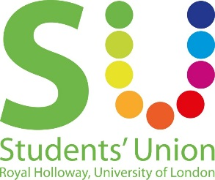
Motion to make a policy on promoting responsible drinking in our venues

This Union Notes:
- That the Students’ Union makes money from bar sales and being a nightclub venue
- That for many students, being at university could be the first time they begin to experiment with alcohol
- That compared to most other clubs/bars/pubs we have a duty of care to our members
- That it is not the responsibility of the Union to parent students, but to ensure the safety of everyone who uses the venues in either night time or day time
- There have been demands for more events less focused on alcohol consumption, and that we have a diverse student body and what we offer should reflect that
- That we have been a pilot union for the Alcohol Impact Initiative, giving us a golden opportunity to look into and tackle issues that arise
This Union Believes:
- As a Students’ Union, we owe our membership a comprehensive commitment to encourage and enable responsible alcohol consumption.
- We should promote a community which recognises and respects different attitudes towards alcohol use.
- We should take very seriously our legal duty of care to our students, staff and visitors and aim to provide a safe, healthy and high quality work and study environment.
- We should promote and encourage student groups to run and engage with events that are alcohol free to ensure an inclusive community.
This union resolves:
- To make a responsible drinking policy for the union to use as a frame of reference for the SU on function nights and for the staff who work in the SU.
- For the policy to encompass all of the above.

This Union Mandates:
- The Co-President Welfare & Diversity (Sidonie) to make this policy document with Staff following the guidance from this motion
- Then for the Co-President Welfare & Diversity (Sidonie) to run it by the Community Council and the Inclusion & Representation Council when drafted.

Proposed: Sidonie Bertrand-Shelton (Co-President Welfare & Diversity)

Seconded: Emma Peagam (President Education & Campaigns)

