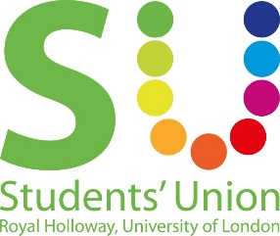
Motion to introduce an Interfaith & Belief Rep to the Inclusion & Representation Council

This Union Notes:
- That faith and belief are protected characteristics in the Equality Act 2010.
Religion has the meaning usually given to it but belief includes religious and philosophical beliefs including lack of belief (e.g. Atheism). Generally, a belief should affect your life choices or the way you live for it to be included in the definition.
- That the Festival of Faith & Cultures in One World Week was a huge success, and the first inter-faith event that was student led in the Students’ Union in a long while.
- That there are issues that affect all students of faith on campus, for example research by the NUS in 2014 found that students of faith and belief were far more likely to feel isolated and vulnerable. They were also far more likely to seek help and support from friends, family or their personal tutor than University or Student Union advice centres.

This Union Believes:
- That inter-faith and belief representation within the Students’ Union is important in order to work with all of the faith and belief societies on campus, including those which may not already be established (such as Jewish Society).
- That as a Students’ Union, we could engage with faith and belief students better in order to work on the things mentioned in ‘This Union Notes’

This Union Resolves:
- To create an Interfaith & Belief Rep to sit on the Inclusion & Representation Council, alongside the Mature & Part Time Students Rep and the Parents & Carers Rep.
- For this position to be elected at the same time as the other representative positions.
- For this position to make a Festival of Faith & Cultures event every year.

This Union Mandates:
- The Co-President Welfare & Diversity (Sidonie) to make this happen.

Proposed by: Sidonie Bertrand-Shelton (Co-President Welfare & Diversity)

Seconded by:
Chris Huckle (Christian Union President)
Jess Kinney (Setting up the Royal Holloway Secularist, Atheist and Humanist Society)
Elly Kennedy (Catholic Society President)
Mahdi Ahmed (Islamic Society President)
Brianna Middleton Macpherson (Co-President Societies & Media)
H Beverley
Jack Kilker (LGBT+ Society President)
Farah Bobdiwala
Nadia Ali

Resources:
Equality Act 2010
NUS Isolation & Vulnerability Report 2014

