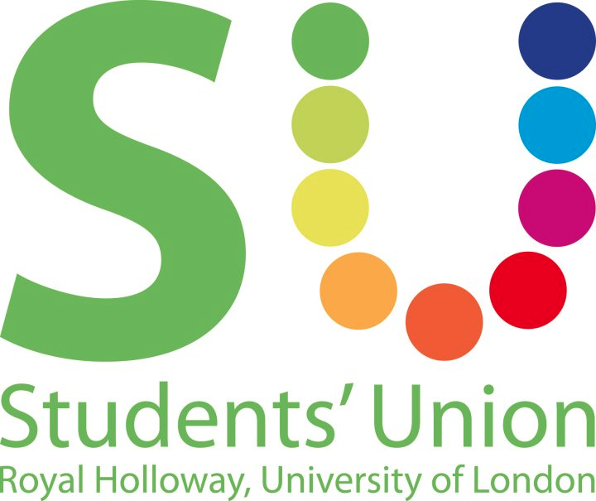

Motion to establish a Liberation Committee to guarantee the successful, year-on-year delivery of History Month Campaigns

This union notes:
- History Month Campaigns refer to: Black History Month, Disabled History Month, LGBT History Month and Women’s History Month.
- At present, no body exists to coordinate and run Liberation History Months at Royal Holloway and to ensure that they are accessible and intersectional.
- History Month Campaigns need to be considerate of and accessible to the needs of all SURHUL members.
- History Month Campaigns need to encompass and celebrate individuals who are at intersections between liberation groups, and their unique set of experiences.
- History Months are important for...
  - ...the representation of liberation groups
  - ...allowing these groups to reclaim lost histories
  - ...educating wider society on issues faced by liberation groups
- It is important that we provide a structure in which campaigns can be run, and which can be dedicated to making these campaigns a priority. (However, education around liberation groups should not be limited to one month.)
- This year, LGBT History Month and Women’s History Month included a range of well-attended and -received events, workshops, and charity fundraising.

This union believes:
- The Co-President Welfare & Diversity and the Liberation Officers of the SU Executive Committee should strive to provide accessible, intersectional and educational history months, to represent and engage members, and to encourage diversity on our campus.
- To be successful year-on-year, there must be a structure for the facilitation of History Month Campaigns.
- History Month campaigns should be a priority for Liberation Officers, as they provide a central point for events and campaigns, and as such, should be allotted considerable time and attention throughout the year.

This union resolves:
- To mandate each Liberation Officer, with support from the Co-President Welfare & Diversity, to deliver a plan for their relevant History Month and present this, in sufficient time, to the Inclusion & Representation Council. The relevant Liberation Officer(s) to each month will have a veto over decisions concerning the History Month they represent, to ensure autonomy for each Liberation Campaign within this committee.
- To mandate the Co-President Welfare & Diversity and the 4 elected Liberation Officers to meet once every two weeks during term time to discuss and plan for History Months.
- The work they carry out should ensure that events as part of these campaigns consider access needs, have an educatory element, and are intersectional.
- These meetings should be open to input from students, such as those representing relevant societies (LGBT+, Feminist, Faith and Cultural Societies, etc.) and be open to the President Education & Campaigns, the Campaigns Officer and the International Students Officer, as well as the Postgraduate Officer, Mature & Part Time Students’ Representative, Student Parents & Carers Representative, Interfaith Representative.
- To mandate the Liberation Officers and Liberation Officer Elects to meet before the end of this academic year, at least twice, in order to establish the parameters for what will be expected of each History Month going forward, and to establish a preliminary calendar of events for Black History Month, which falls in October.

Proposed by: Sidonie Bertrand-Shelton (Co-President Welfare & Diversity)

Seconded by: Jack Kilker (Co-President Welfare & Diversity Elect); Alexandra Sophia (LGBT+ Officer); Sobaan Shariff (LGBT+ Officer Elect); Natasha Barrett (Women & Marginalised Genders Officer Elect); Molly Coulthard (Disabled Students’ Officer Elect); Josephine Chick (LGBT+ Officer); Alex Reilly (Co-President Sports & Development Elect); Laura Lewis (LGBT+ Officer Elect);

Proposal:
Liberation Committee
Chair Elected at first meeting

Members Co-President Welfare & Diversity
Women & Marginalised Genders Officer
Disabled Students’ Officer
Black & Minority Ethnicities Officer
LGBT+ Officer
Any interested students

In attendance President Education & Campaigns
Campaigns Officer
International Students’ Officer
Postgraduate Officer
Mature & Part Time Students’ Representative
Student Parents & Carers Representative
Interfaith Representative

Frequency of Meetings Every other week during term time

Quorum 50% of voting members including one Sabbatical Officer

Purpose
- To coordinate, plan and create the events and campaigns of the liberation History Months
- Shall strive for these to be as intersectional and accessible as possible

Terms of Reference
- Shall liaise with the Co-President Welfare & Diversity
- Shall work together to support each other’s History Months, in order to ensure they are intersectional and consistent
- Shall try to create events and/or campaigns that are accessible to International Students, Postgraduates, Mature & Part Time, Student Parents & Carers and Interfaith.
- Each History Month should aim to have both some self-defining only sessions and some for the wider community
- Each History Month should have an planned educational outcome.
- The Liberation Committee will invite relevant Societies / interested students to take part in the meetings, plannings and running of events
- The History Months are:
  - Black History Month (October)
  - Disabled History Month (22nd Nov - 22nd Dec)
  - LGBT+ History Month (February)
  - Womens’ History Month (March)

Reports to Inclusion & Representation Council

Committees reporting to this committee None

