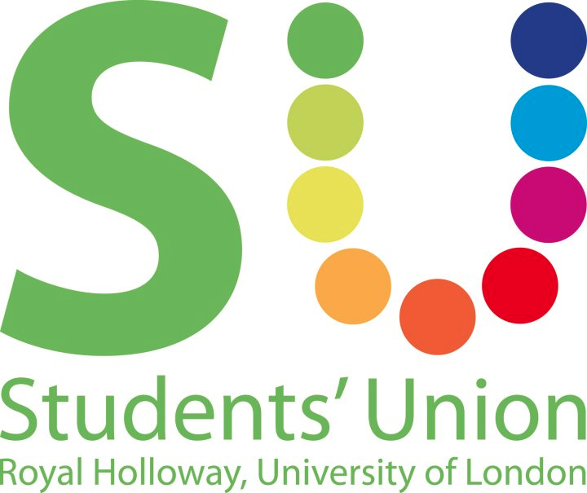

Motion to adopt Safe Space Policy

This Union Notes:
- As a Students’ Union we represent all of our students and endeavour to ensure their time at university is as enjoyable and rewarding as possible.
- Although we already have policies for Equality & Diversity against discrimination, a Safe Space policy takes it a step further to ensure that every member should feel welcome to participate in empowering, non-judgemental and non-threatening discussions, activities, services and events. Members should be free from intimidation, harassment and the deliberate, or negligent, creation of unsafe or unwelcoming conditions.
- That many other Students’ Unions, including the NUS have Safe Space Policies
- That the Co-President Welfare & Diversity has looked at over ten other Union Safe Space policies to compile this draft, and consulted with staff and students on it.

This Union Believes:
- SURHUL is committed to creating a safe, tolerant and inclusive environment so that all students are able to participate in Union events, activities and affairs that are free from bullying, harassment, intimidation, aggressive, violent, oppressive and discriminatory behaviour.
- That we need a practical guide and policy to instruct best practice for clubs, societies and executive officers. The following is a draft proposal after much work.

This Union Resolves:
- To adopt this Safe Space Policy

This Union Mandates:
- The Co-President Welfare & Diversity and President Education & Campaigns to make this policy

Proposed by: Sidonie Bertrand-Shelton, Co-President Welfare & Diversity

Seconded by: Emma Peagam, President Education & Campaigns

