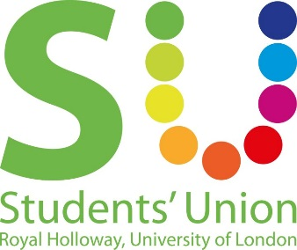
Motion to reinforce Zero Tolerance to Sexual Harassment policy

This Union Notes
- In a survey of 2,156 students by the National Union of Students (NUS) published in September 2015, 37% of women and 12% of men who responded said they had faced unwelcome sexual advances. Under UK law "inappropriate touching and groping" constitutes sexual assault, though the survey does not use the term. More than a third of women (36%) who took part in the survey said they had experienced unwanted sexual comments about their body compared with 16% of men. Two-thirds said they had seen students tolerate unwanted sexual comments, and just under a third reported gender-based verbal harassment. The survey suggested the telling of rape and sexual assault jokes was commonplace, with two-thirds of those taking part admitting to witnessing it in the university environment.
- That the NUS’ definition of sexual harassment is as follows: The defining characteristics of sexual harassment are that it is unwanted, persistent and of a sexual nature. Examples of unacceptable behaviour include: - Unwanted sexual comments (including comments about your body or private life) - Unwelcome sexual invitations, innuendoes, and offensive gestures - Wolf whistling, catcalling or offensive sexual noises - Groping, pinching or smacking of your body, such as your bottom or breasts - Having your skirt or top lifted without agreeing - Someone exposing their sexual organs to you without consent
- The zero tolerance to sexual harassment campaign has been established by the NUS Women’s Campaign. The zero tolerance campaign aims to help unions create an environment where all students can enjoy time in their union without persistent and unwanted attention of a sexual nature.
- That we have already passed this policy, and are just reinforcing it as it has come out of date.
- That sexual harassment can happen to anyone of any gender.

This Union Believes
- That no student at this institution should be forced to just ‘put up’ with sexual harassment, and that action must be taken to ensure all students are able to enjoy the union without experiencing sexual harassment
- That sexual harassment should not be tolerated by the union, and those who commit acts of sexual harassment should be stopped and disciplined for their actions.
- That the “I Heart Consent” campaign has been very useful in starting conversations around consent and sexual harassment, over 170 students have taken the workshop with an overwhelmingly positive outcome. 26 Students have been trained to deliver the workshops themselves.

This Union resolves
- To continue to adopt the Zero Tolerance Policy to Sexual Harassment

This Union Mandates:
- The Co-President Welfare & Diversity to continue to lead on this policy.

Proposed by: Sidonie Bertrand-Shelton (Co-President Welfare & Diversity)

Seconded by:
Natasha Barrett (Feminism Society President)
Jack Kilker (LGBT+ Society President)
Laura Lewis
H Beverly
Molly Coulthard
Imogen Tyreman
Tara El Kashef
Sobaan Sharif
Gillian Craig
Nadia Ali
Farah Bobdiwala

